Low Level Design

Food Recommendation System

| Written By | Ankur Das, Rahul Pidkalwar |
| --- | --- |
| Document Version | 0.3 |
| Last Revised Date | 23 – May -2021 |

**Document Control**

### Change Record:

| **Version** | **Date** | **Author** | **Comments** |
| --- | --- | --- | --- |
| 0.1 | 19 – May -  2021 | Ankur Das | Introduction & Architecture defined |
| 0.2 | 20 – May -  2021 | Rahul Pidkalwar | Architecture & Architecture Description appended and updated |
| 0.3 | 21 – May -  2021 | Ankit Singh Chauhan | Unit Test Cases defined and appended |
|  |  |  |  |
|  |  |  |  |
|  |  |  |  |

### Reviews:

| **Version** | **Date** | **Reviewer** | **Comments** |
| --- | --- | --- | --- |
| 0.2 | 21 – May -  2021 | Khusali | Document Content , Version Control and Unit Test Cases to be added |

### Approval Status:

| **Version** | **Review**  **Date** | **Reviewed By** | **Approved By** | **Comments** |
| --- | --- | --- | --- | --- |
|  |  |  |  |  |

Contents

1. **Introduction** 1
   1. **What is Low-Level design document?** 1
   2. **Scope** 1
2. **Architecture** 2
3. **Architecture Description** 3
   1. **Data Description** 3
   2. **Web Scrapping** 3
   3. **Data Transformation** 3
   4. **Data Insertion into Database** 3
   5. **Export Data from Database** 3
   6. **Data Pre-processing** 3
   7. **Data Clustering** 3
   8. **Model Building** 4
   9. **Data from User** 4
   10. **Data Validation** 4
   11. **User Data Inserting into Database** 4
   12. **Data Clustering** 4
   13. **Model Call for Specific Cluster** 4
   14. **Recipe Recommendation & Saving Output in Database** 4
   15. **Deployment** 4
4. **Unit Test Cases** 5

# Introduction

## What is Low-Level design document?

The goal of LLD or a low-level design document (LLDD) is to give the internal logical design of the actual program code for Food Recommendation System. LLD describes the class diagrams with the methods and relations between classes and program specs. It describes the modules so that the programmer can directly code the program from the document.

## Scope

Low-level design (LLD) is a component-level design process that follows a step-by-

step [refinement](https://en.wikipedia.org/wiki/Refinement_(computing)) process. This process can be used for designing data structures, required software architecture, source code and ultimately, performance algorithms. Overall, the data organization may be defined during requirement analysis and then refined during data design work

# Architecture

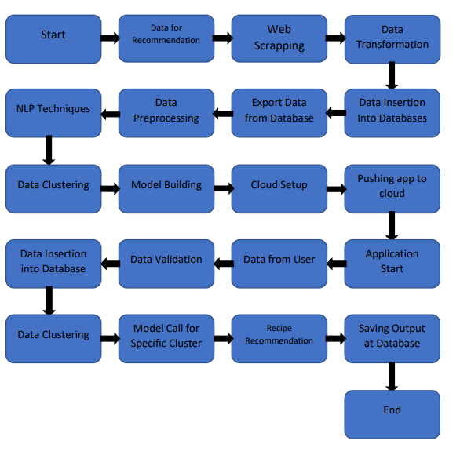

# Architecture Description

## Data Description

Recipe 1M+ dataset is the biggest publicly available recipe dataset. The information each recipe contains is separated in two JavaScript Object Notation (JSON) files. This dataset contains 1029715 recipes including 1480 different ingredients.

## Web Scrapping

In order to create a more complete recipe collection we will need some more datasets which will contain Nutritional value of recipes along with Ratings and total Calories.

## Data Transformation

In the Transformation Process, we will convert our original dataset which is in JSON format to CSV Format. And will merge it with the Scrapped dataset.

## Data Insertion into Database

1. Database Creation and connection - Create a database with name passed. If the database is already created, open the connection to the database.
2. Table creation in the database.
3. Insertion of files in the table

## Export Data from Database

Data Export from Database - The data in a stored database is exported as a CSV file to be used for Data Pre-processing and Model Training.

## Data Pre-processing

Data Pre-processing steps we could use are Null value handling, stop words removal, punctuation removal, Tokenization, Lemmatization, TFIDF, Imbalanced data set handling, Handling columns with standard deviation zero or below a threshold, etc.

## Data Clustering

K-Means algorithm will be used to create clusters in the pre-processed data. The optimum number of clusters is selected by plotting the elbow plot. The idea behind clustering is to implement different algorithms to train data in different clusters. The K-means model is trained over preprocessed data and the model is saved for further use in prediction

## Model Building

After clusters are created, we will find the best model for each cluster. For each cluster, algorithms will be passed with the best parameters derived from Grid-Search. We will calculate the AUC scores for models and select the model with the best score. Similarly, the models will be selected for each cluster. All the models for every cluster will be saved for use in Recommendation.

## Data from User

Here we will collect physiological data from user such as user height and weight, heart rate, burned calories, daily physical activity level; as well as information directly provided by the user such as daily food intake

## Data Validation

Here Data Validation will be done, given by the user

## User Data Inserting into Database

Collecting the data from the user and storing it into the database. The database can be either MySQL or Mongo DB.

## Data Clustering

The model created during training will be loaded, and clusters for the user data will be predicted.

## Model Call for Specific Cluster

Based on the cluster number, the respective model will be loaded and will be used to predict/Recommend the data for that cluster.

## Recipe Recommendation & Saving Output in Database

After calling model Recipe/Output will be recommended, this output will be saved in Database and it will beused to show the same Output if other users provide the same data.

## Deployment

We will be deploying the model to AWS.

This is a workflow diagram for the Recipe Recommendation..

# Unit Test Cases

| **Test Case Description** | **Pre-Requisite** | **Expected Result** |
| --- | --- | --- |
| Verify whether the Application URL is  accessible to the user | 1. Application URL  should be defined | Application URL should be  accessible to the user |
| Verify whether the Application loads completely for the user when the URL is accessed | 1. Application URL is accessible 2. Application is deployed | The Application should load completely for the user when the URL is accessed |
| Verify whether the User is able to sign  up in the application | 1. Application is  accessible | The User should be able to sign up  in the application |
| Verify whether user is able to successfully login to the application | 1. Application is accessible 2. User is signed up to the application | User should be able to successfully login to the application |
| Verify whether user is able to see input fields on logging in | 1. Application is accessible 2. User is signed up to the application 3. User is logged in   to the application | User should be able to see input fields on logging in |
| Verify whether user is able to edit all input fields | 1. Application is accessible 2. User is signed up to the application 3. User is logged in to the application | User should be able to edit all input fields |
| Verify whether user gets Submit button to submit the inputs | 1. Application is accessible 2. User is signed up to the application 3. User is logged in to the application | User should get Submit button to submit the inputs |
| Verify whether user is presented with recommended results on clicking  submit | 1. Application is accessible 2. User is signed up to the application 3. User is logged in   to the application | User should be presented with recommended results on clicking  submit |
| Verify whether the recommended results are in accordance to the selections user made | 1. Application is accessible 2. User is signed up to the application 3. User is logged in to the application | The recommended results should be in accordance to the selections user made |
| Verify whether user has options to filter the recommended results as well | 1. Application is accessible 2. User is signed up | User should have options to filter the recommended results as well |

|  | to the application  3. User is logged in to the application |  |
| --- | --- | --- |
| Verify whether KPIs modify as per the user inputs for the user's health | 1. Application is accessible 2. User is signed up to the application 3. User is logged in to the application | KPIs should modify as per the user inputs for the user's health |
| Verify whether the KPIs indicate details of the suggested recipe | 1. Application is accessible 2. User is signed up to the application 3. User is logged in to the application | The KPIs should indicate details of the suggested recipe |